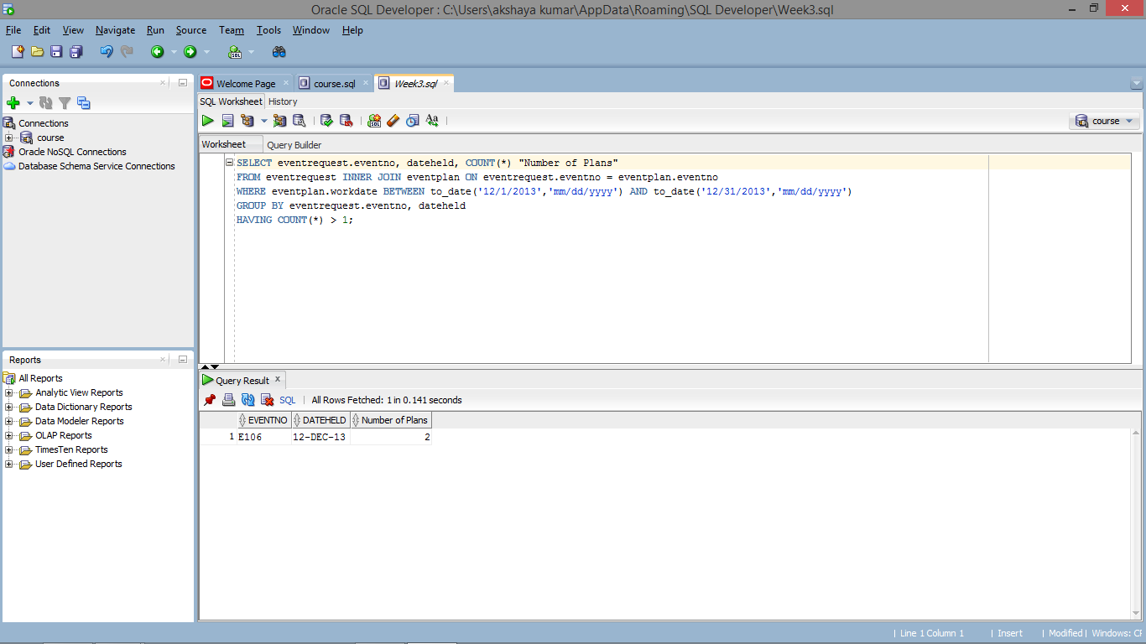

SELECT eventrequest.eventno, dateheld, COUNT(*) "Number of Plans"

FROM eventrequest INNER JOIN eventplan ON eventrequest.eventno = eventplan.eventno

WHERE eventplan.workdate BETWEEN to_date('12/1/2013','mm/dd/yyyy') AND to_date('12/31/2013','mm/dd/yyyy')

GROUP BY eventrequest.eventno, dateheld

HAVING COUNT(*) > 1;